**Learning Outcomes**

* Understanding Auto-complete textview
* Understanding Checkbox and Radio-button

**Auto-complete text view**

This is another input type controls. This is similar to EditText control, except that; it has a collection from which it would give you suggestion once you start typing. The minimum length for typing is 2.

First of all we create a resource array. Resource arrays are defined in Strings.xml.

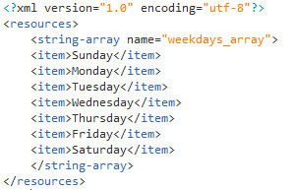

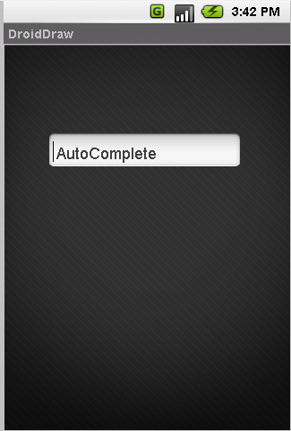

**Code**

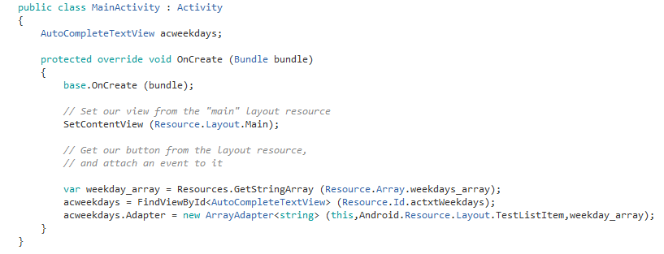

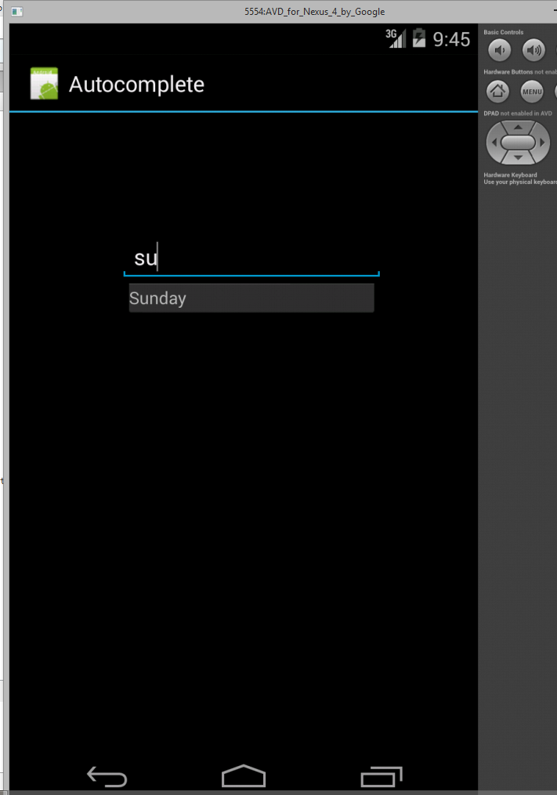

Using an array inside the code

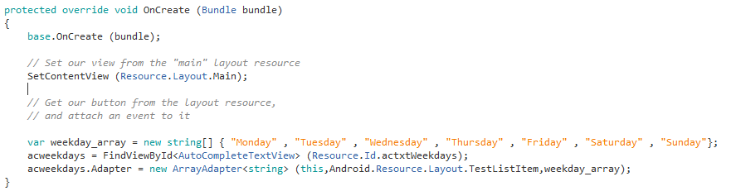

**Checkbox and Radio Button**

Design a layout with checkboxes in it

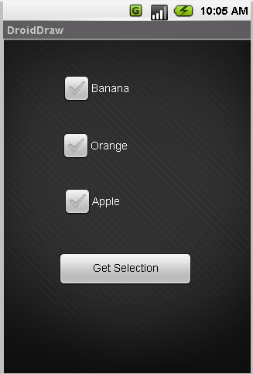

Declare your Checkboxes and Buttons

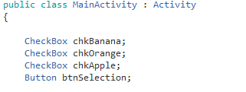

Initialize the controls and attach click even to it

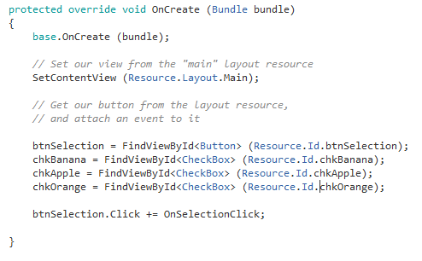

Show toast messages on click of the Button

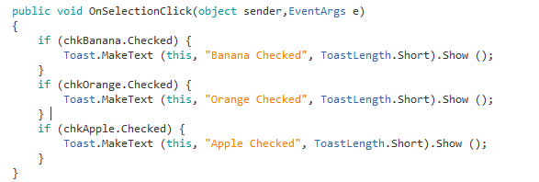

**Radio-Button**

To add radio-buttons first we need to group them together using a radio group control

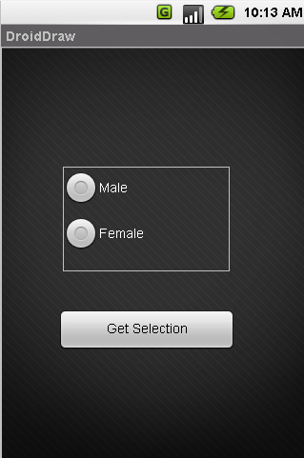

Radio group

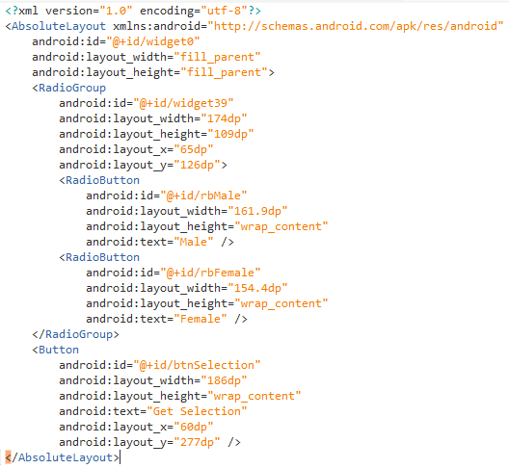

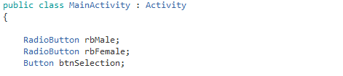

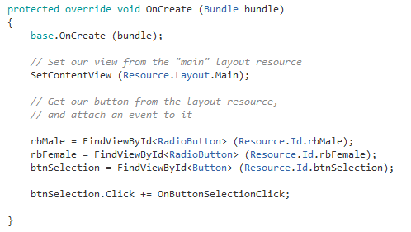

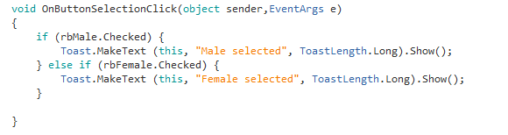

**Exercise**

Implement the Temperature Converter app

